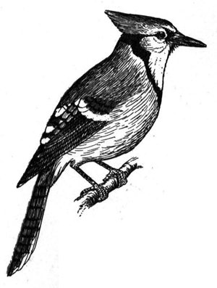
Exam Request for an Excused Absence

I have a conflict on the following date and would like to request an excused absence. I understand that to be considered for an excused absence, I must meet the requirements and expectations listed in the Jewell School Band / Choir Grading Policy.

Student Name:______________________________________
Group (Circle One) Concert Band (9-12) Middle School Band (7-8) 6th Grade Band Beginning Band (4-5th)

Dates of Absence (s) ______________________________________________

Reason: ______________________________________________________________________

(Use back of sheet if necessary)

I understand that I must make up the time (perform the concert selections in front of an audience as a solo) I will miss within a week (or the marking period) of my absence. I understand that if I fail to make up the time and work, the absence becomes unexcused. Thank you for your consideration in this matter.

Proposed date of make-up ____________________________ Time: _____________________

Student ___________________________________ Date: _____________________________

Parent ____________________________________ Date: _____________________________
-------------Office Use Only-----------

EXCUSED ________ UNEXCUSED________ Make Up Work Completed____________

Make Up Playing Exam Rubric:
Woodwind & Brass Percussion
Right Notes 4 3 2 1 Steady Tempo 4 3 2 1
Tone Quality 4 3 2 1 Accurate Rhythm 4 3 2 1
Accurate Rhythm 4 3 2 1 Correct Dynamics 4 3 2 1
Preparation 4 3 2 1 Preparation 4 3 2 1
Music Marked 4 3 2 1 Music Marked 4 3 2 1

Score________________ Grade______________

A = 19-20 B = 17-18 C = 15-16 D = 13-14 F = 11-12

